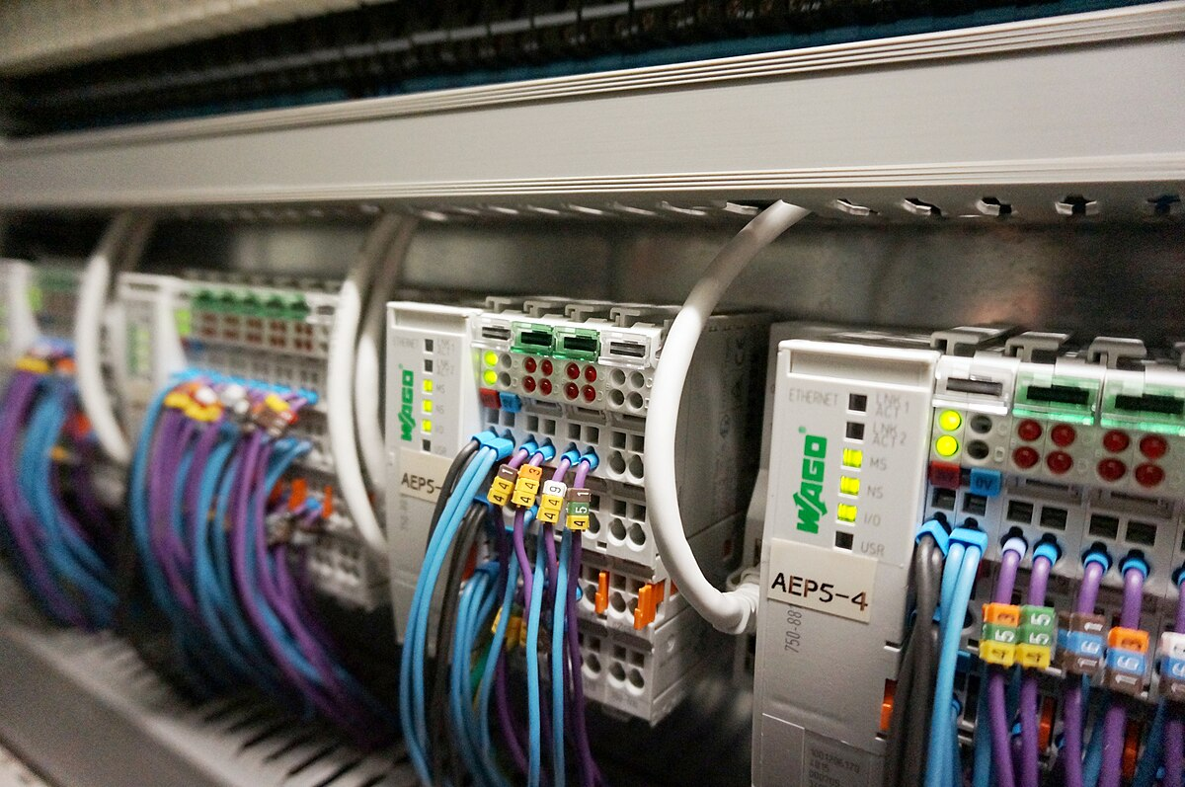Presented To: Dr. Mohamed Omar

MCT313   
Automation

Major Task Phase Two

Production Line

Eng. Nourhan Emad

Eng. Mina El Kess

Presented By: Team 7

Omar Mohamed Mohamed 21P0274

Omar Waleed 21P0083

Yahia Mohamed 21P0041

Table of Contents

1.0 ABSTRACT 4

2.0 INTRODUCTION 4

3.0 PROJECT OVERVIEW 4

3.1 System Description 4

3.2 Project Objectives 5

4.0 STATIONS 6

4.1 Feeding Station 6

4.2 Sorting Station 7

4.3 Machining Station 8

4.4 Assembling Station 10

5.0 CONTROL LOGIC 12

5.0 HMI 12

5.1 HMI Screens 12

6.0 SYSTEM ALARMS 15

8.0 CONCLUSION 19

9.0 REFERENCES 19

10.0 APPENDIX 19

Table of Figures

Figure 1 Factory IO scene 6

Figure 2 Feeding Station 7

Figure 3 Vision Sensor Used in Sorting 7

Figure 4 Sorting Station 8

Figure 5 Machining station 9

Figure 6 Machining exit sensor 9

Figure 7 Assembly Station 10

Figure 8 Assembly Vision sensor and Pneumatic Pusher 10

Figure 9 Products in assembly position 11

Figure 10 conveyor with orienting device 11

Figure 11 Vantage Point 12

Figure 12 Root screen 13

Figure 13 Machining screen 14

Figure 14 Assembly Screen 14

Figure 15 Control and DAQ screen 15

Figure 16 Products accumulated 16

Figure 17 Machining station stuck 17

Figure 18 Alarms visible in HMI 17

Figure 19 Feeding station stalled 18

Figure 20 Robot Failure 18

Figure 21 Robot grab failure 19

# ABSTRACT

This report details the design, implementation, and simulation of an automated production line using Siemens TIA Portal and a simulation platform (e.g., Factory I/O). The project's objective was to create a full-functioning production line capable of generating raw materials, machining them into bases and lids, assembling finished products, sorting them by color, and tracking production counts. The system incorporates a comprehensive PLC program for sequence control, an HMI for monitoring and supervisory control, and a robust alarm system for fault detection. Hardware-in-the-loop (HIL) or software-in-the-loop (SIL) simulation was employed to validate the control logic and system performance. The report highlights the system architecture, control strategies, HMI design, alarm implementation, and presents the results obtained from the simulation, demonstrating the successful automation of the production process.

# 2.0 INTRODUCTION

Industrial automation plays a critical role in modern manufacturing, enabling increased efficiency, productivity, and consistency. Production lines are central to mass production, requiring precise control and coordination of various stations and processes. The complexity of these systems necessitates effective design, programming, and testing methodologies. Simulation platforms provide a valuable environment for developing and validating automation solutions in a virtual setting before deploying physical hardware, reducing risks and development time. This project focuses on the automation of a simulated production line, encompassing key manufacturing operations: feeding, machining, assembly, and sorting. Utilizing Siemens TIA Portal for PLC programming and HMI development, alongside a simulation environment, this project aims to demonstrate the principles of designing and implementing a complete automation solution for a multi-station industrial process. The report will detail the steps taken to achieve the project objectives, the technical implementation, and the performance of the automated system.

# 3.0 PROJECT OVERVIEW

## 3.1 System Description

The automated production line designed for this project is a multi-station system simulated within the Factory IO environment. The physical layout of the line is configured to facilitate a sequential manufacturing process, starting from raw material introduction and concluding with the assembly of finished products. The line comprises several key components, including:

* a Feeding Unit equipped with a pick and place robot for initial material handling
* a sorting station with a vision sensor to transfer products to their specified machining center
* a Machining Center featuring an articulated robot and a CNC machine for fabricating product components (lids and bases)
* an Assembly Unit where bases and lids are combined to form complete products using another Pick and Place Cartesian Robot.

Material transfer between stations is facilitated by a network of conveyors, some of which are configured with analog control capabilities to manage flow rate and prevent bottlenecks.

The system also incorporates various sensors, such as diffuse and proximity sensors to detect part presence and position, and vision sensors for part identification or inspection if added to the design. Actuators, including motors for conveyors and robots, as well as pneumatic cylinders and robotic effectors, are utilized to perform the necessary physical manipulations of the workpieces.

## 3.2 Project Objectives

The core objective of this project was to design and control a simulated production line using Siemens TIA Portal, demonstrating key automation principles for manufacturing processes.

Specific goals included:

* Designing a complete production line for machining, sorting, and assembly of green/blue products from raw materials.
* Implementing control logic for the feeding station (including pick & place), machining center (with different machining times), and assembly station.
* Developing a sorting mechanism for raw materials based on color.
* Creating an HMI for monitoring station status, product counts, and supervisory control.
* Implementing analog control for conveyors and pick & place units.
* Developing logic for dynamic conveyor speed control based on Process conditions.
* Designing a fault detection system with alarms for hardware and sequence faults.
* Ensuring the line stops upon reaching a target product count for each color.

These objectives aim to simulate a realistic industrial automation scenario and showcase proficiency in PLC programming, HMI design, and system integration within a simulation environment.

# 4.0 STATIONS

This section provides a detailed description of each major station comprising the automated production line, following the implemented material flow of Feeding -> Sorting -> Machining -> Assembly. Each station plays a specific role in the overall manufacturing process, from the initial introduction and sorting of raw materials to the final assembly of finished products. The design and functionality of each station were implemented within the simulation environment and controlled by the PLC program developed in TIA Portal.

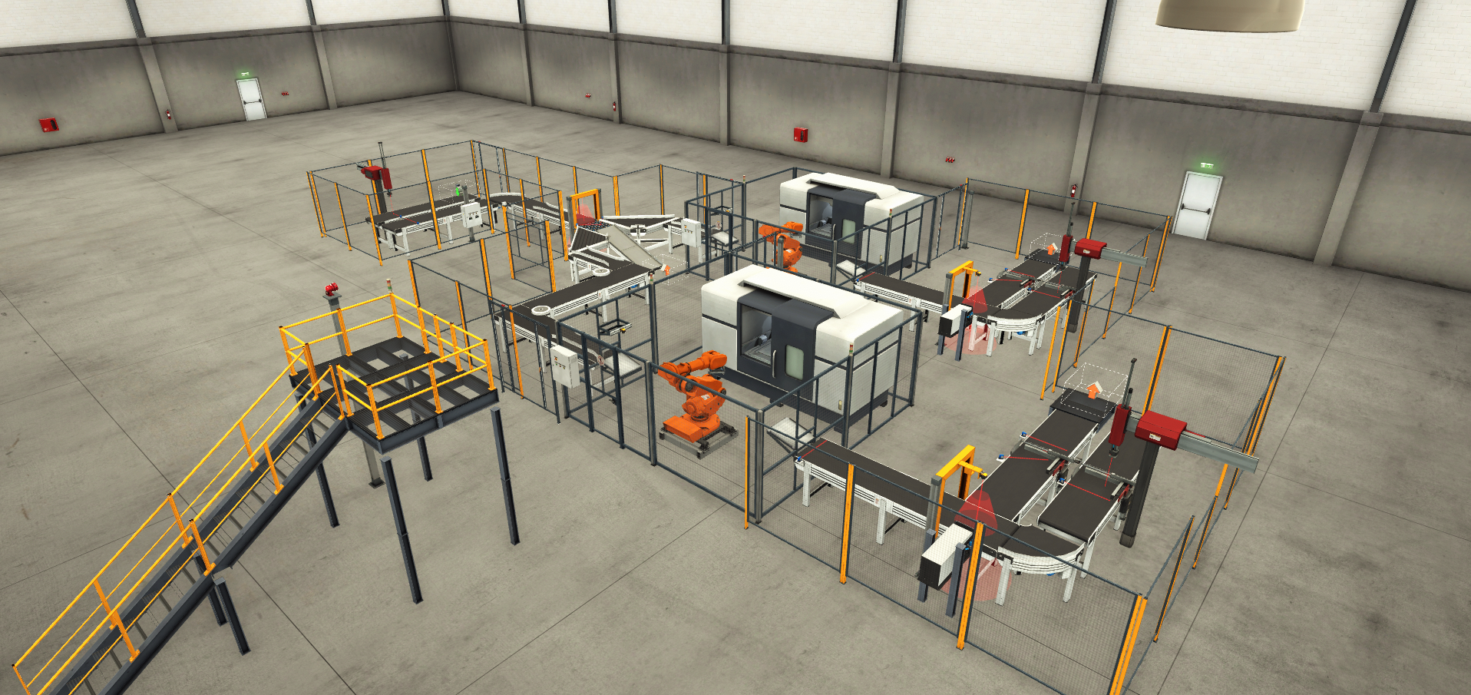

Figure 1 Factory IO scene

## 4.1 Feeding Station

The Feeding Station serves as the entry point for raw materials in the production line. Its primary function is to generate random raw materials, which are specified as either green or blue. The station is equipped with a basic pick and place robot. This robot is responsible for picking up the generated raw materials and accurately placing them onto the output conveyor of the feeding unit, initiating their journey through the subsequent stages of the production line. The sensor installed on the entry conveyor informs the Robot about the existence of a product beneath its end effector, The robot starts to move to grab the product and move it to the exit conveyor to begin its journey. The sensor on the exit conveyor is responsible for restarting the entrance conveyor to bring in the next product.

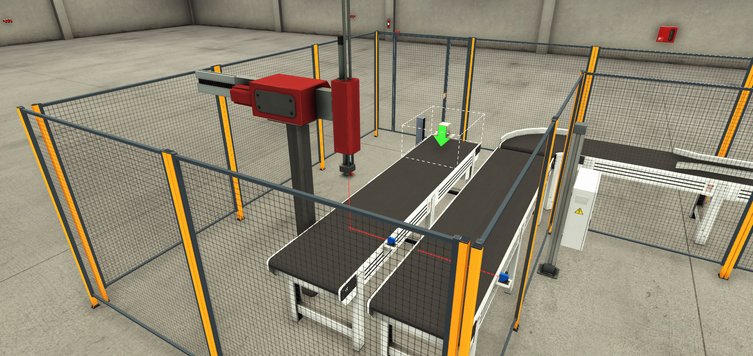

Figure 2 Feeding Station

## 4.2 Sorting Station

Immediately following the Feeding Station, the Sorting Station is responsible for segregating the incoming raw materials based on their color (green or blue). As raw materials arrive at this station via conveyor from the feeding unit, sensors are used to identify the color of each item.

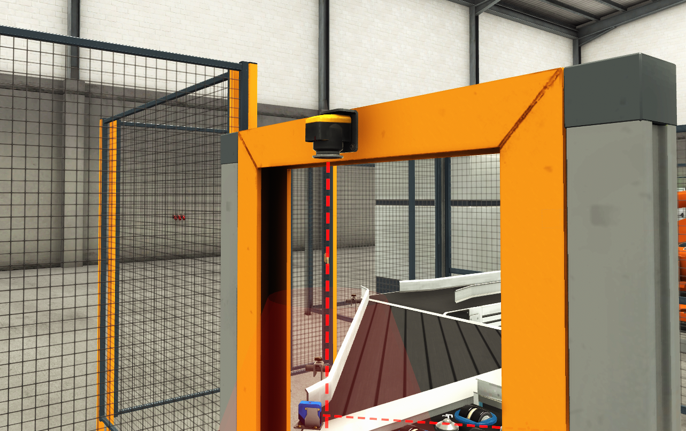

Figure 3 Vision Sensor Used in Sorting

Based on this color detection, the sorting mechanism is activated to divert the raw material onto the appropriate conveyor path leading to either the machining station for green products or a different path for blue products. And if the Number of raw materials needed to assemble the required number of products is reached, extra products are redirected to storage for upcoming orders.

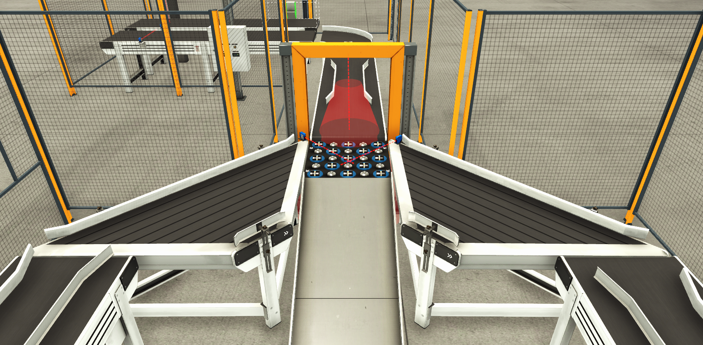

Figure 4 Sorting Station

## 4.3 Machining Station

The Machining Station is where the raw materials are transformed into the components required for assembly: lids and bases. This station features an articulated robot and a CNC machine. Sorted raw materials arrive at an entry bay, where the articulated robot picks them up and loads them into the CNC machine. The CNC machine then processes the material to create either a lid or a base. The machining process alternates between producing a lid and then a base from consecutive raw materials of the same color. The time required for machining differs between lids (6 seconds) and bases (3 seconds), a factor accounted for in the control logic. Once the machine is complete, the robot retrieves the finished component from the CNC machine and places it onto an exit bay conveyor, from where it proceeds to the assembly station.

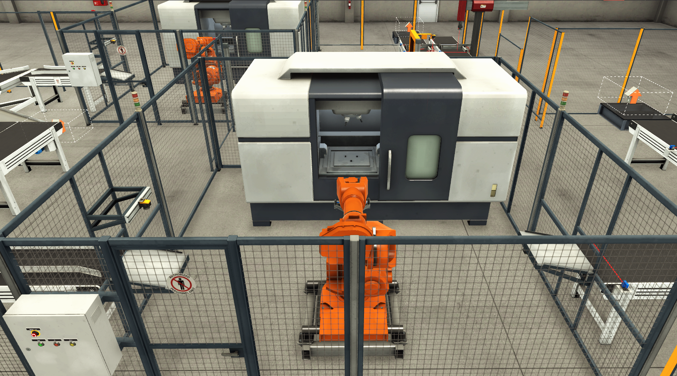

Figure 5 Machining station

The sensor placed at the exit conveyor of the machining is responsible for the interchanging between the manufacturing of the Lid and the Base.

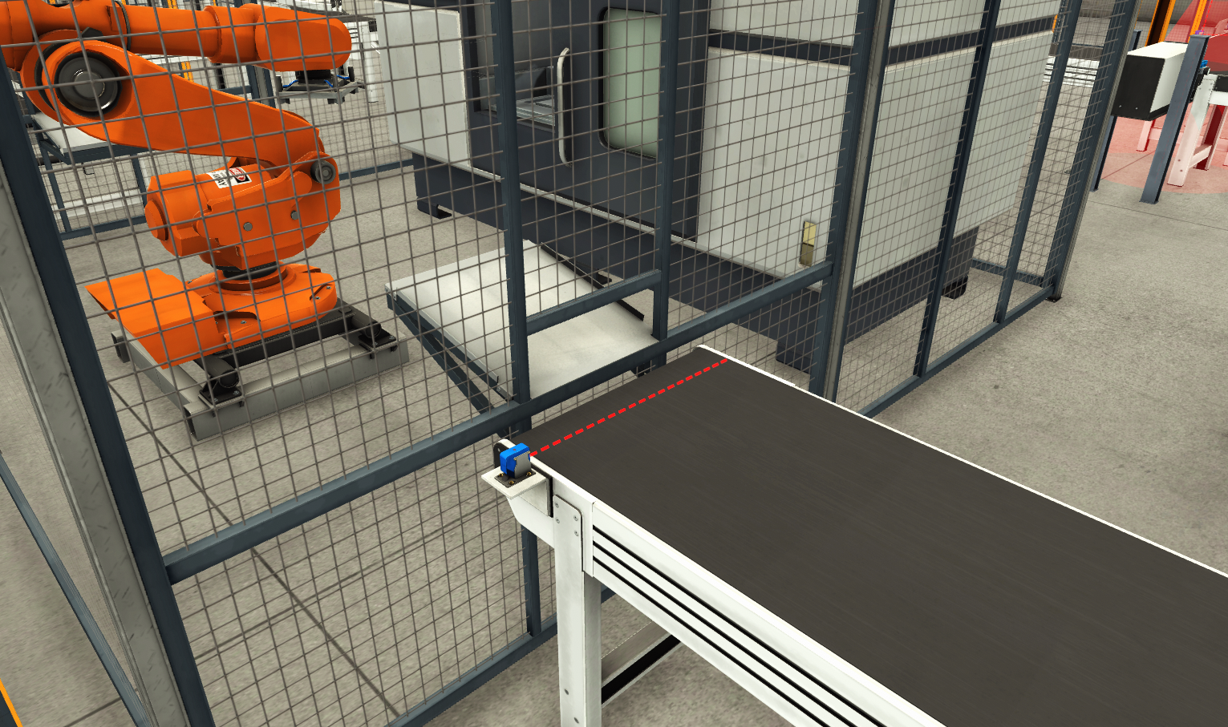

Figure 6 Machining exit sensor

## 4.4 Assembling Station

The Assembling Station is where the final product is created by joining a lid and a base. As components arrive at this station, a vision sensor is utilized to detect whether the incoming part is a base or a lid.

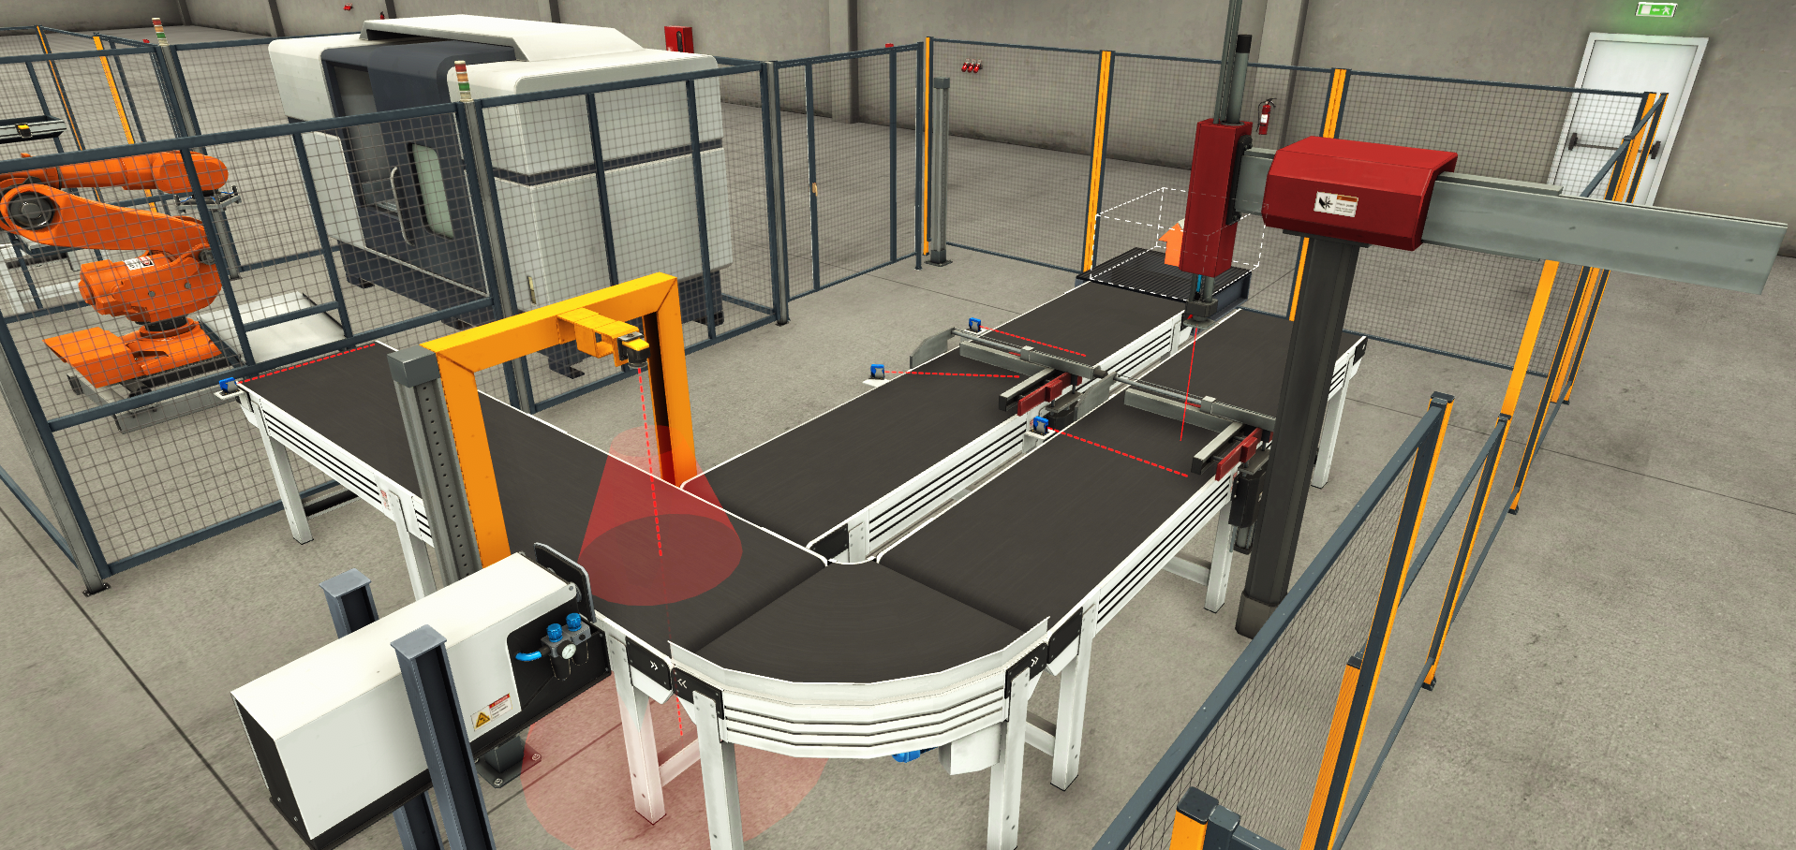

Figure 7 Assembly Station

If the vision sensor identifies a base, a pusher mechanism activates to transfer it onto a designated first conveyor. Here, the base is clamped and oriented precisely to prepare it for the assembly process. If the vision sensor identifies a lid, the part continues moving along the conveyor to a second conveyor, where it is also clamped and oriented correctly.

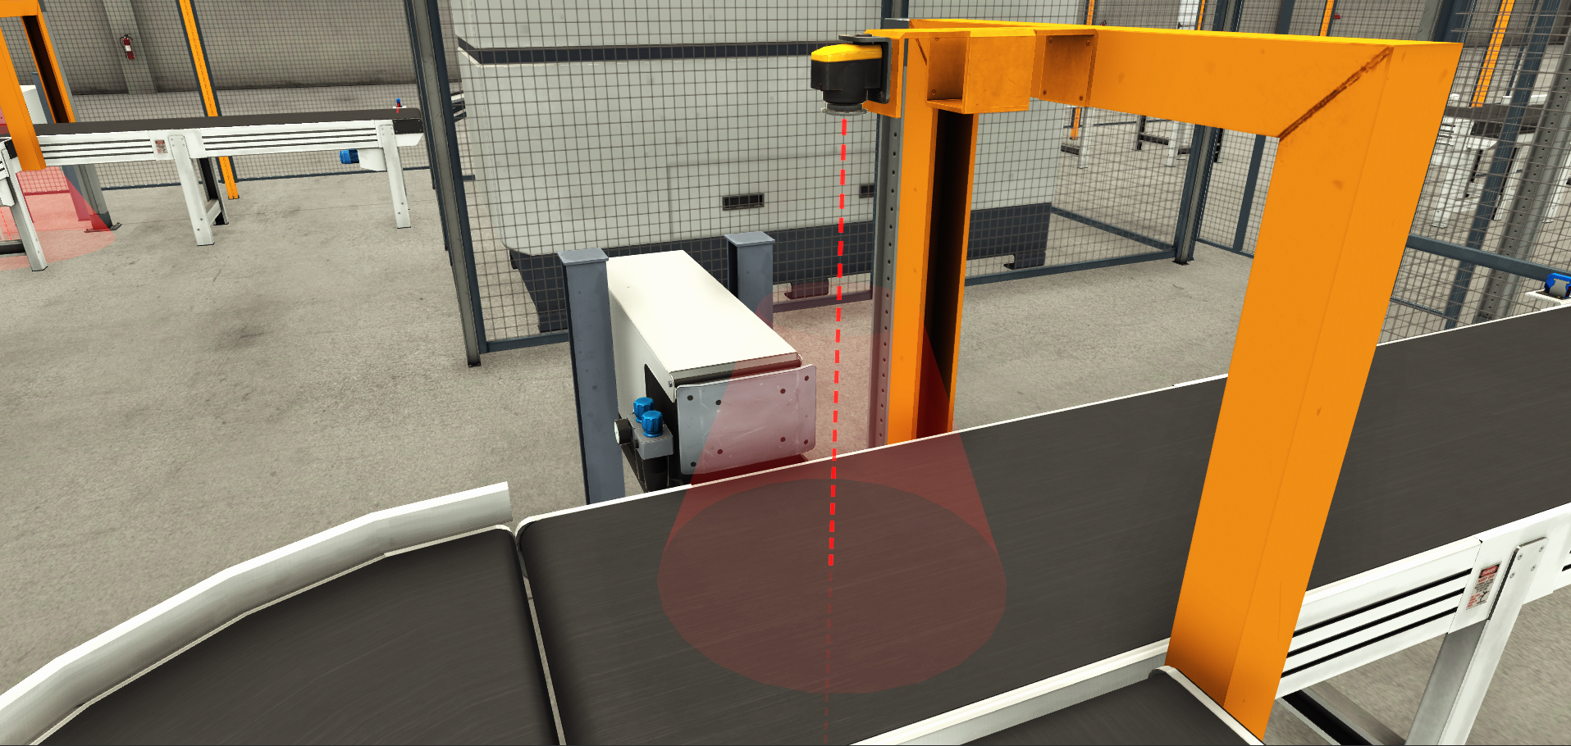

Figure 8 Assembly Vision sensor and Pneumatic Pusher

Once both a clamped base and a clamped lid are in position, a pick and place robot initiate its sequence. The robot picks up the lid from the second conveyor and accurately places it onto the base located on the first conveyor, thereby assembling the product. Following the assembly, the robot returns to its original position.

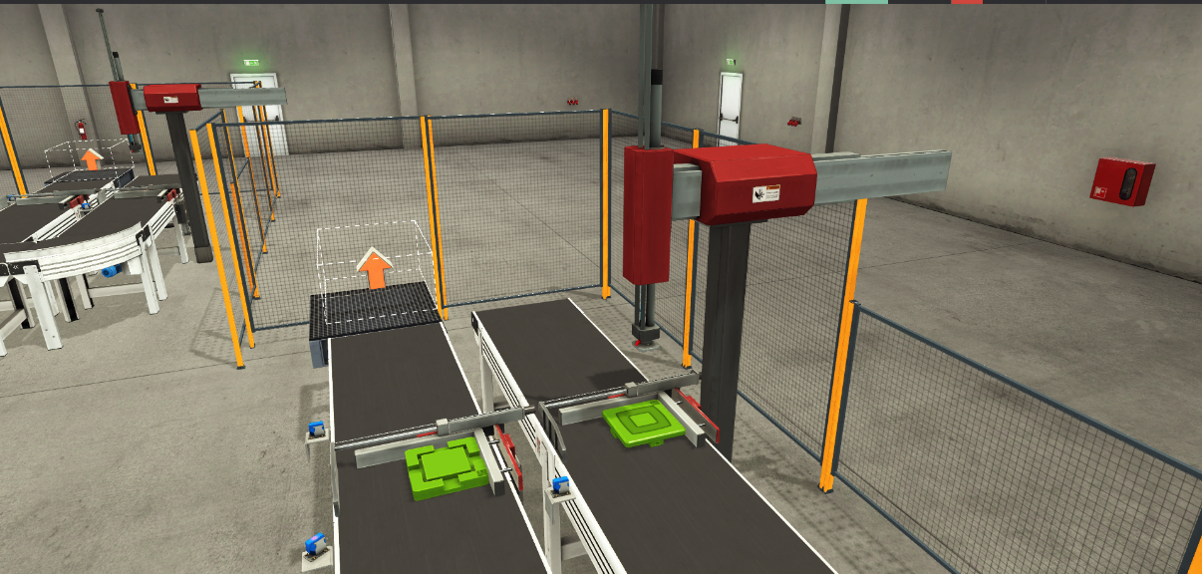

Figure 9 Products in assembly position

Subsequently, the clamper holding the assembled product releases its grip and retracts upwards, allowing the conveyor to resume movement and transport the completed product to the next stage (which is not covered in the scope of this specific project). This station's operation relies heavily on the coordinated control of sensors, pushers, conveyors, clampers, and the pick and place robot to ensure accurate and efficient assembly.

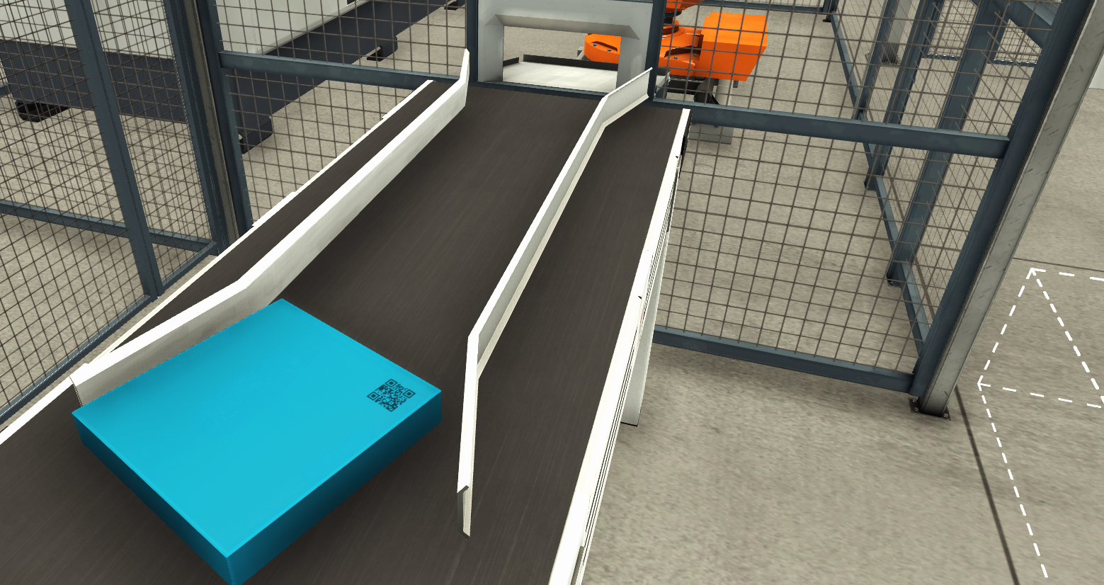

Figure 10 conveyor with orienting device

All these stations are connected by a network of conveyors of different sizes. These conveyors are equipped with mounted orienting devices designed to maintain the correct orientation of the products as they move between stations. This is crucial for preventing bottlenecks, particularly in tight spots or transfer points, and ensuring that components arrive at each station in the proper alignment for subsequent operations.

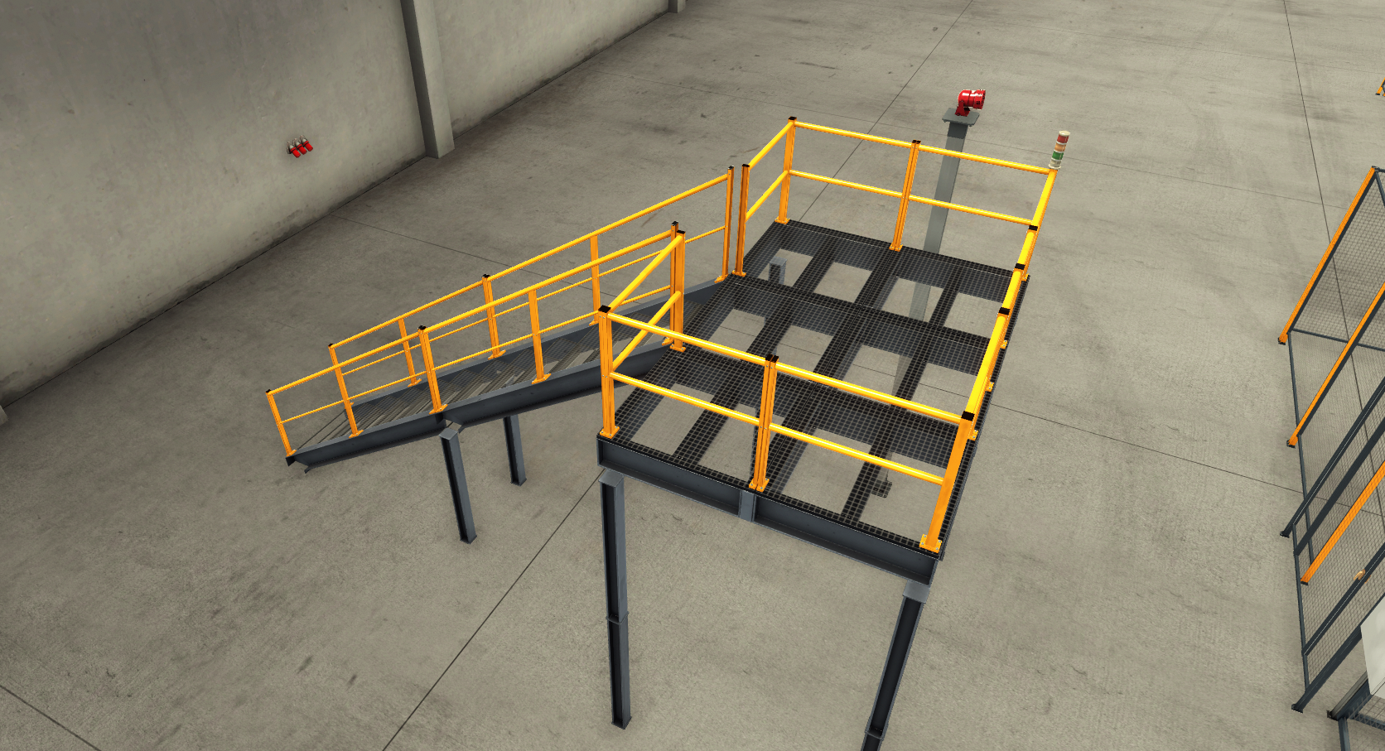

Figure 11 Vantage Point

To enhance visualization and understanding of the system's operation, a dedicated vantage point has been included in the simulation environment, providing a comprehensive overview of the entire production line.

# 5.0 CONTROL LOGIC

# 5.0 HMI

The Human-Machine Interface (HMI) provides the operator with a visual interface to monitor the status of the production line, view system information, and interact with the control system. Designed in Siemens TIA Portal, the HMI allows for real-time visualization of station states, product counts, and active alarms, enabling effective supervision and control of the automated process.

## 5.1 HMI Screens

The HMI is organized into four distinct screens to provide a clear and logical overview of the production line's operations:

1. **Root Screen:** This serves as the main navigation hub of the HMI. It contains buttons or links to access the other three station-specific screens. Additionally, this screen prominently displays a list of current errors and warnings, providing immediate notification of any system anomalies.

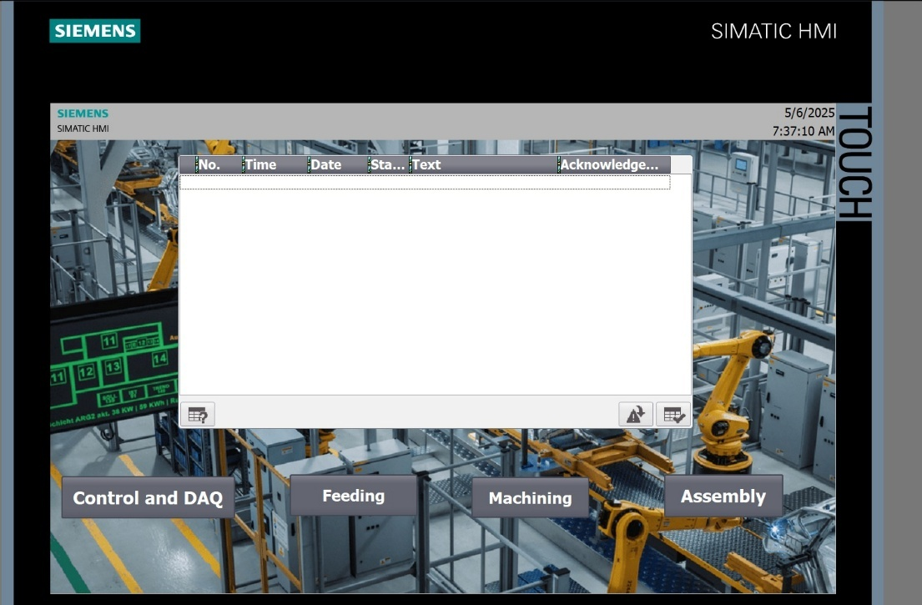

Figure 12 Root screen

1. **Feeding Screen:** This screen is dedicated to visualizing the status and operation of the Feeding Station. It will display relevant information such as the current state of the feeding unit, the status of the pick and place robot, and potentially controls related to raw material generation or conveyor speed within this station.

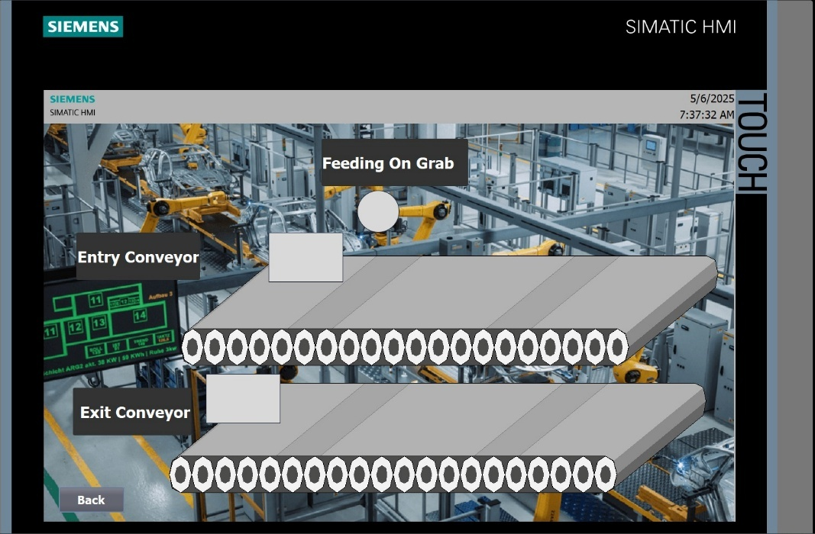

1. **Machining Screen:** This screen provides detailed information about the Machining Station. It includes indicators to show if the machining center is currently busy processing a product, a progress indicator for the ongoing machining operation, and information specifying whether the product being manufactured is a base or a lid.

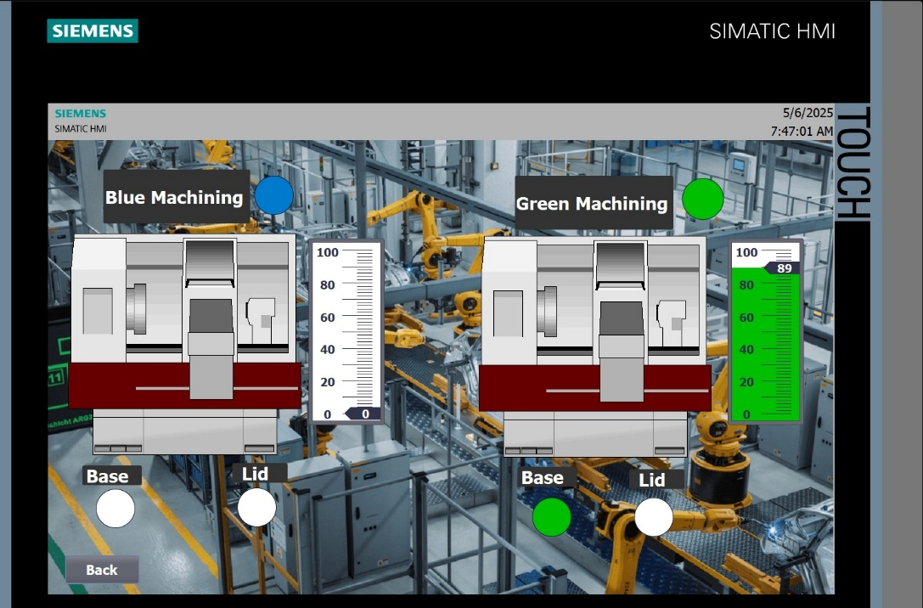

Figure 13 Machining screen

1. **Assembly Screen:** This screen focuses on the Assembling Station. It includes indicators to show when both a base and a lid are detected and ready for assembly, an indicator confirming that the assembly process is currently taking place, and a notification when a finished product has been successfully assembled.

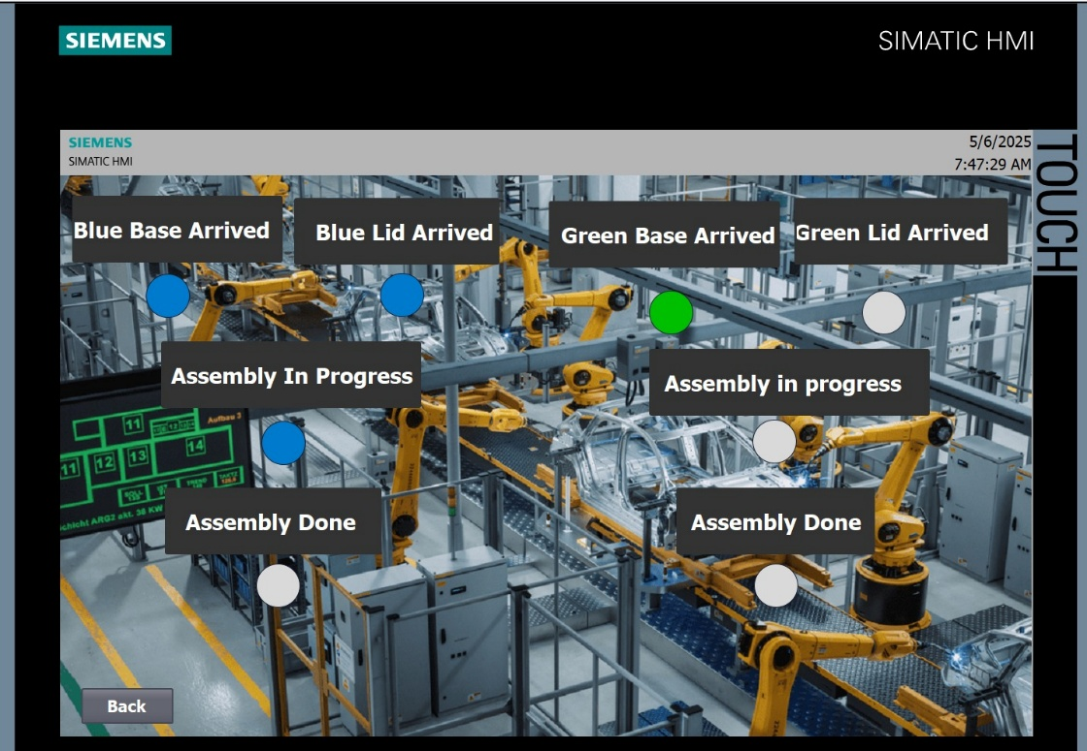

Figure 14 Assembly Screen

1. **Control and DAQ**

The HMI also incorporates several interactive elements and displays for operator control and data acquisition. A prominent feature is a slider control that allows for the adjustment of conveyor speeds. This analog control is implemented for the conveyors located before and after the machining station, enabling operators to fine-tune material flow rates to optimize throughput and prevent bottlenecks based on the machining process status.

For production management, the HMI includes an input field where the operator can set the target number of finished products to be produced. A separate display shows the current count of assembled products, providing real-time feedback on production progress towards the set target.

Essential control buttons are also present on the HMI, including Start, Stop, and Reset buttons. These allow the operator to initiate, halt, and reset the production line's operation as needed. Furthermore, a blinking LED indicator is integrated into the HMI to provide a clear visual alert whenever an error is detected within the system, drawing the operator's attention to potential issues requiring intervention.

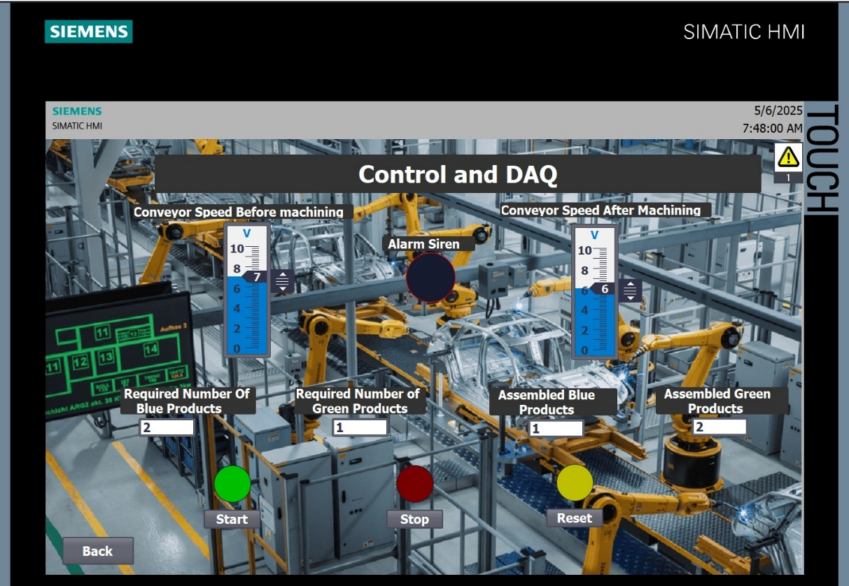

Figure 15 Control and DAQ screen

# 6.0 SYSTEM ALARMS

A critical aspect of the automated system is the implementation of a robust fault detection and alarming system. The HMI includes a dedicated interface for displaying current errors and warnings, providing the operator with immediate feedback on the system's health and any detected anomalies that may disrupt production.

Several specific errors have been implemented to cover potential issues across different stations:

**Machining Entry Accumulation Error**: This error is triggered when products accumulate excessively at the entry points of the machining station for either the blue or green lines. This is detected using two sensors that indicate a prolonged queue of waiting products, suggesting potential issues such as slow machining cycles or physical obstructions on the conveyor.

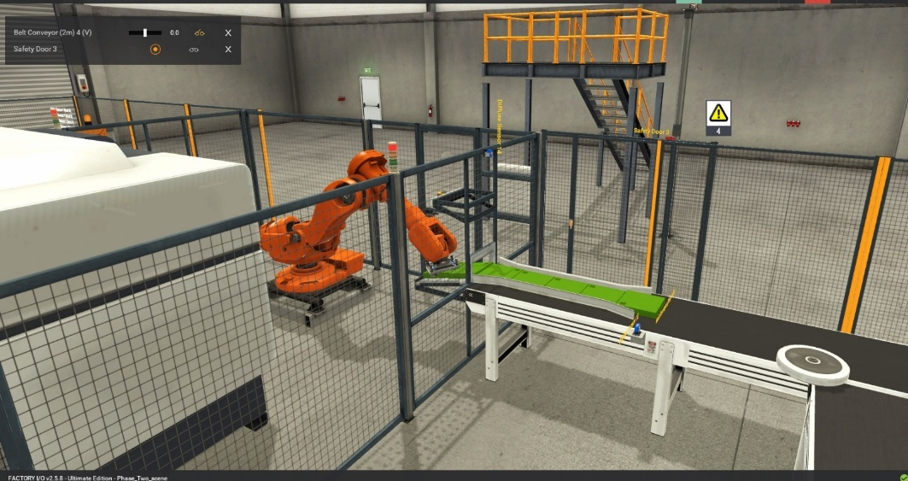

Figure 16 Products accumulated

**Machining Robot Pick-up Error**: An error is generated by the machining station if the articulated robot encounters an issue when attempting to pick up a product. This occurs, for instance, if the system logic indicates a product is ready to be fetched, but the sensor on the robot's end effector fails to detect the product upon reaching the pick-up location. This error is implemented for both machining stations if multiple is used.

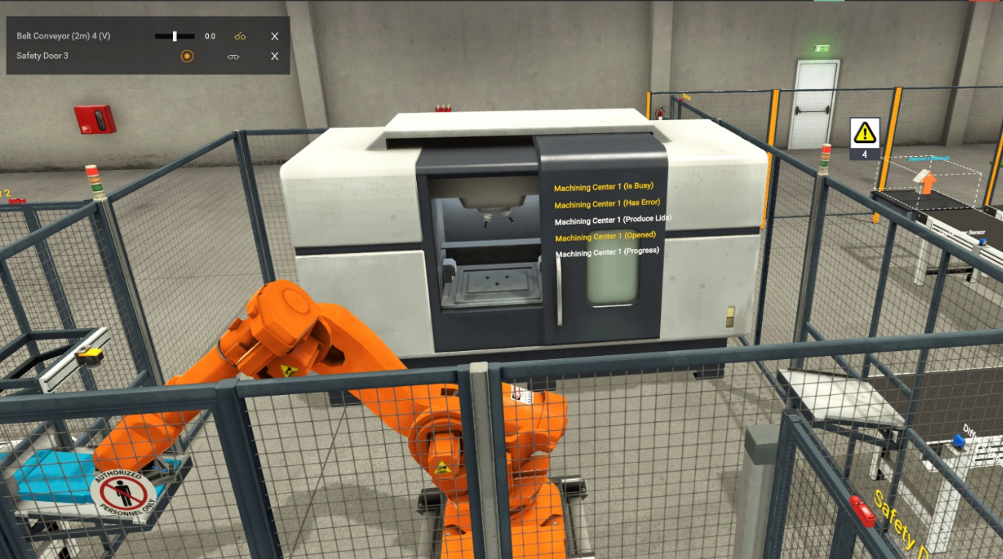

Figure 17 Machining station stuck

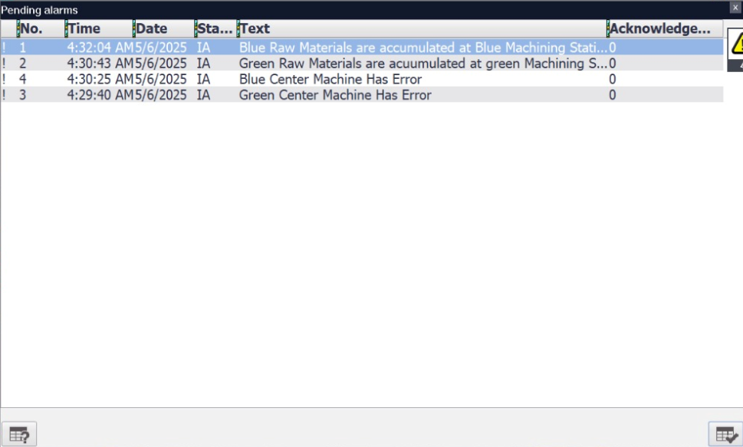

Figure 18 Alarms visible in HMI

**Feeding Station Entry Timeout Error**: This error is activated if a product remains at the entry sensor in the feeding station for longer than 3 seconds. This condition indicates that the feeding robot is not functioning correctly or is unable to pick up the raw material.

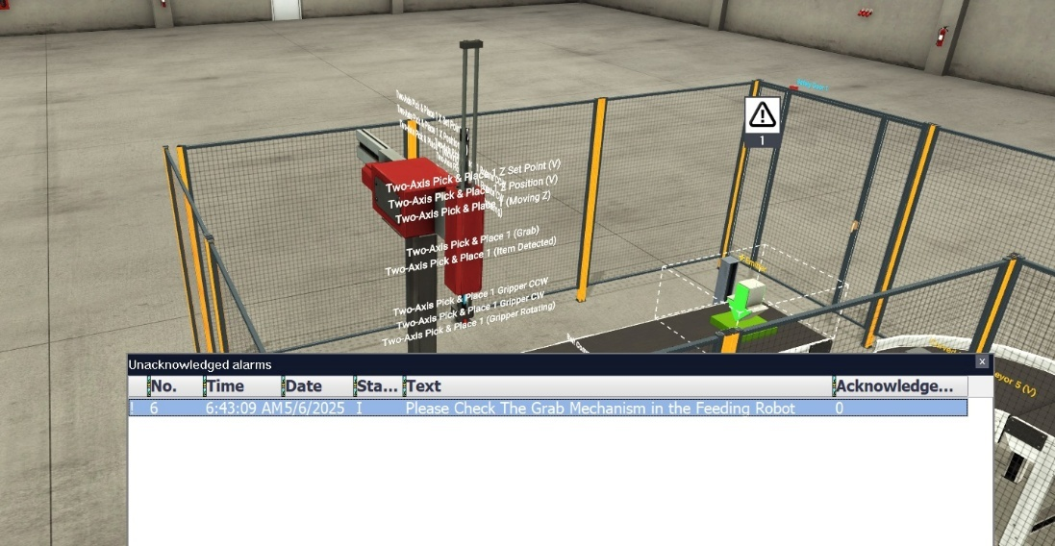

Figure 19 Feeding station stalled

**Robot Grab Failure Error**: This error occurs when a pick and place robot (at either the feeding or assembly station) attempts to grab a product, but the sensor on its end effector loses the signal after the grab action is initiated. This indicates a failure to properly grip or lift the product. The control logic for this error includes resetting the robot's state to allow it to attempt the grab action again.

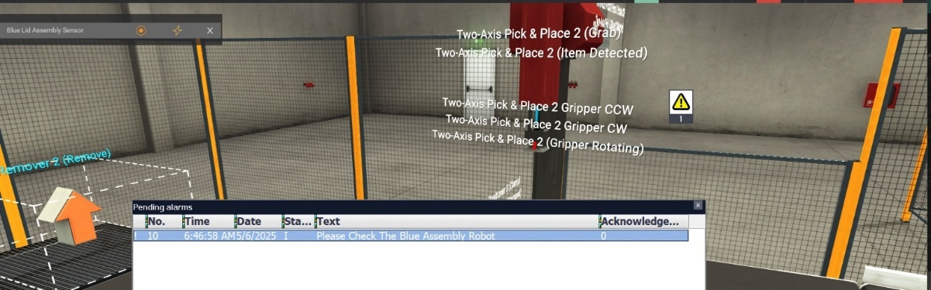

Figure 20 Robot Failure

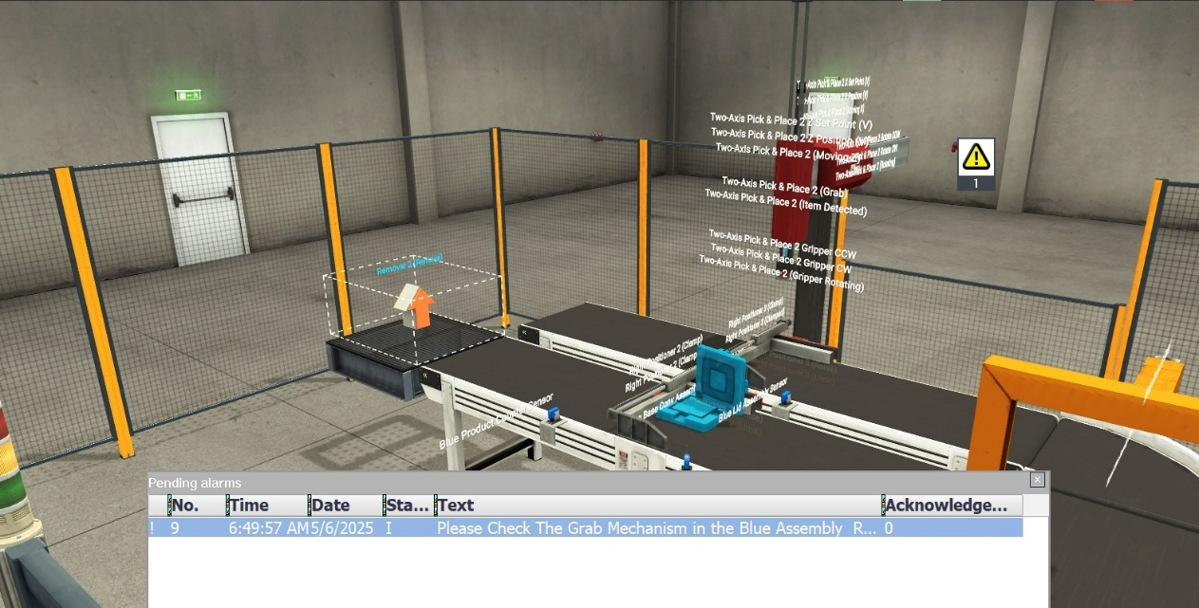

Figure 21 Robot grab failure

These alarms are designed to alert the operator to specific operational issues, enabling prompt intervention to diagnose and rectify the problem, thereby minimizing downtime and maintaining production efficiency.

# 8.0 CONCLUSION

In conclusion, this project successfully designed, implemented, and simulated an automated production line demonstrating key principles of industrial automation. The objectives of creating a multi-station system capable of feeding, sorting, machining, and assembly were met through the development of integrated PLC control logic in Siemens TIA Portal and visualization via a comprehensive HMI. The implementation of a detailed alarm system provides essential fault detection capabilities, enhancing the system's reliability and enabling effective operator intervention. The simulation environment proved invaluable for developing and testing control strategies and station interactions. Key learning was gained in sequencing complex operations, managing material flow with analog control, and designing user-friendly HMI interfaces and robust alarm systems.

# 9.0 REFERENCES

YouTube Channel – Hegamurl: [Tia Portal full Course](https://www.youtube.com/@hegamurl7434/playlists) [1]

Factory IO Manual: [FactoryIO](https://factoryio.com/) [2]

Tia Portal Documentation: [Siemens' Tia Portal](https://support.industry.siemens.com/cs/document/65601780/tia-portal-an-overview-of-the-most-important-documents-and-links-controller?dti=0&lc=en-AO) [3]

# 10.0 APPENDIX

GitHub Project Link: [Industrial Automation Phase Two Project](https://github.com/YahiaRaouf/Automation_Phase_Two.git)